**SOFTWARE ENGINEERING LAB TASK 3**

**11-12-2024**

**HU22CSEN0100287**

**SAI GANESH ESWARAPRASAD**

**Introduction to JIRA Tool**

**1. Introduction**

* **What is JIRA?**  
  JIRA is a project management and issue-tracking software developed by Atlassian. Initially designed for bug tracking, JIRA has evolved into a comprehensive tool for managing workflows, tracking projects, and supporting agile methodologies.
* **Why JIRA?**  
  It enables teams to plan, track, and release software efficiently, making it a preferred choice for developers and project managers worldwide.

**2. Features of JIRA**

* **Issue and Task Tracking:**  
  Track tasks, bugs, and project issues with ease.
* **Agile Boards:**  
  Supports Scrum and Kanban boards for agile development.
* **Roadmaps:**  
  Helps visualize project timelines and dependencies.
* **Custom Workflows:**  
  Design workflows tailored to your team's requirements.
* **Reporting and Analytics:**  
  Get insights through burndown charts, sprint reports, and more.

**3. Benefits of Using JIRA**

* Improves **team collaboration** and communication.
* Provides **real-time insights** into project progress.
* Offers **customizable dashboards** for different team needs.
* Integrates seamlessly with popular tools like Slack, GitHub, and Jenkins.

**4. Use Cases**

* **Software Development Teams:** Manage sprints, backlogs, and releases.
* **IT Operations:** Track incidents and service requests.
* **Marketing Campaigns:** Plan and execute campaigns effectively.
* **Recruitment:** Manage the hiring process with JIRA workflows.

**5. Setting Up JIRA**

1. 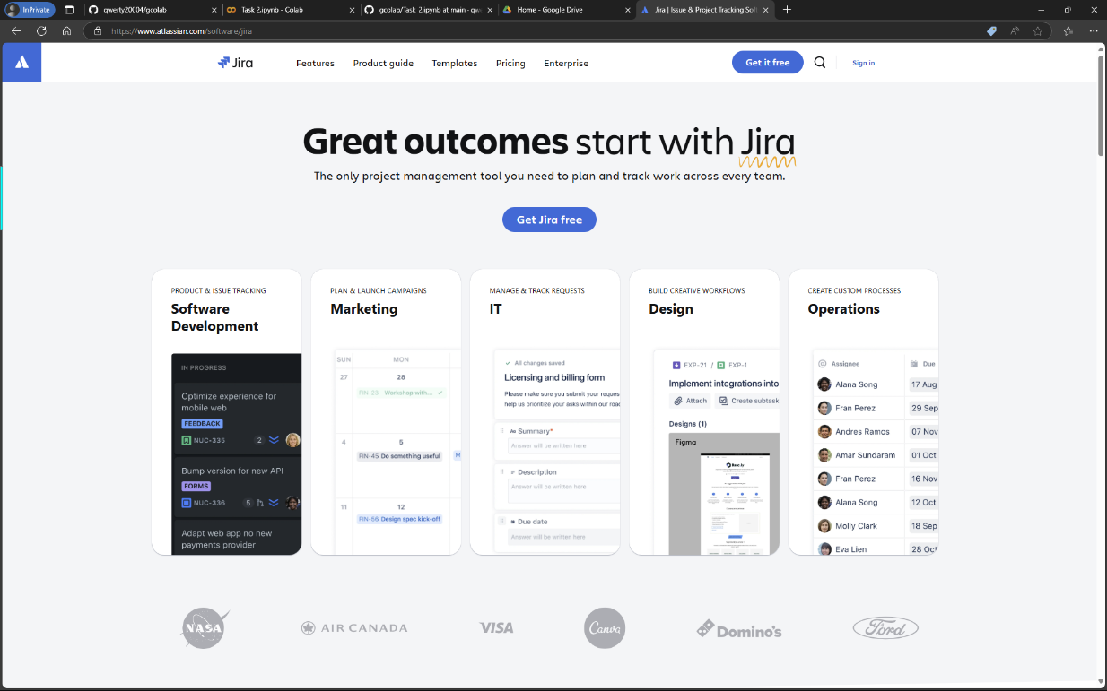**Sign-Up:**  
   Visit https://www.atlassian.com/software/jira and create an account.

1. **Click on ‘Create your account”  
   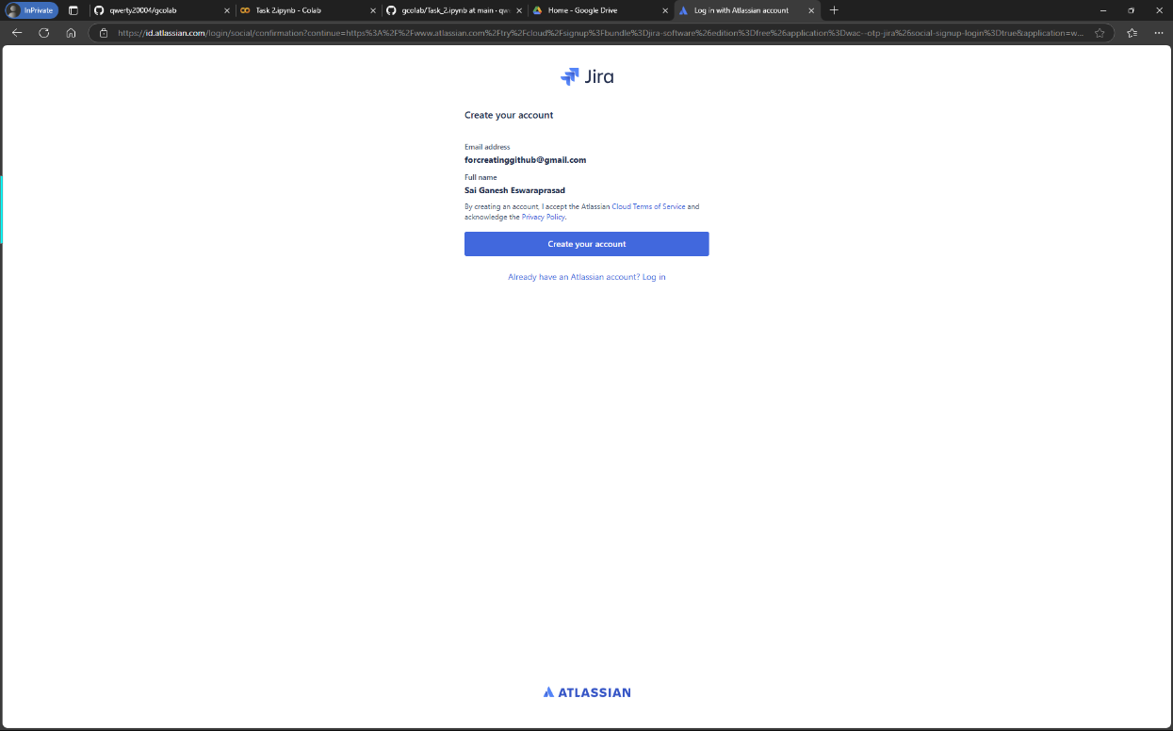**
2. **Name you site**

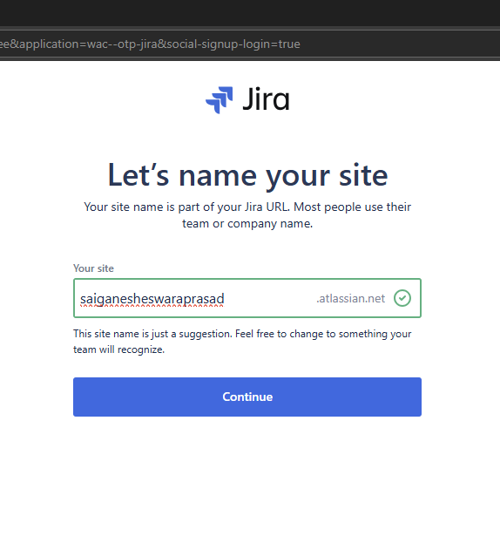

1. **Choose the respective details**

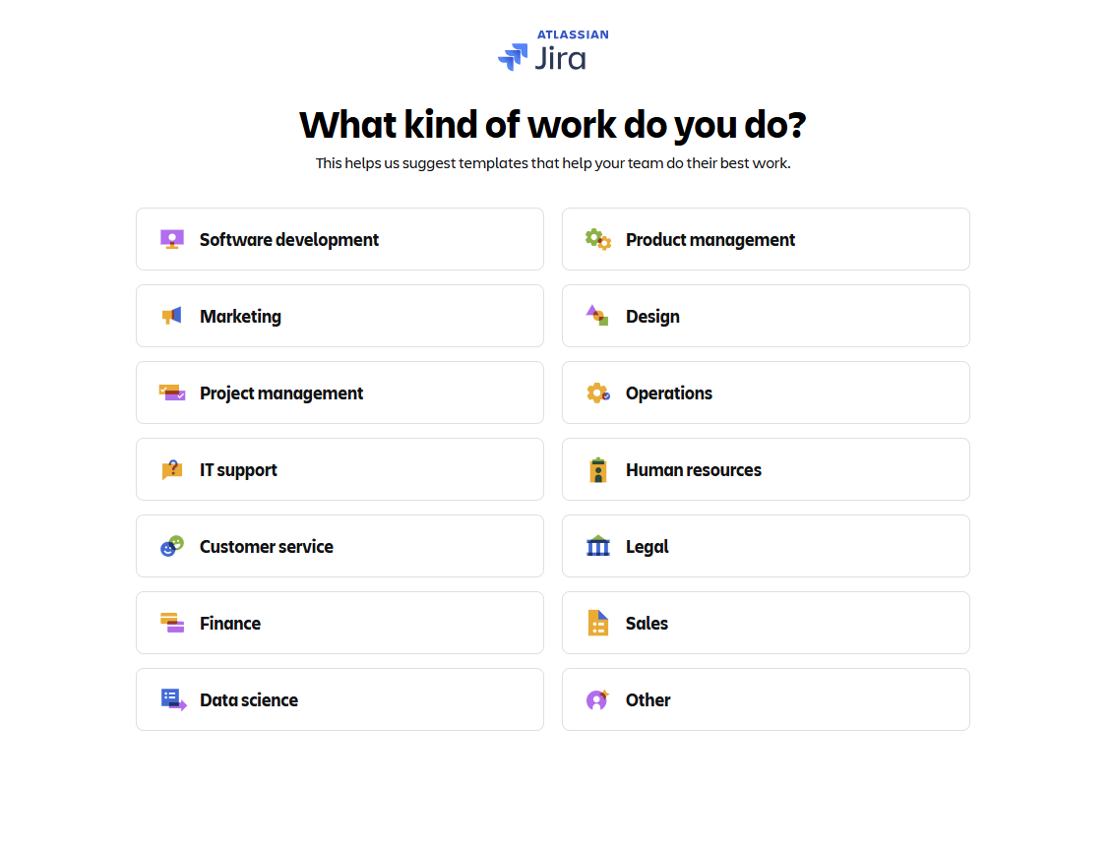

1. Choose “**How does your team plan to use Jira?”**

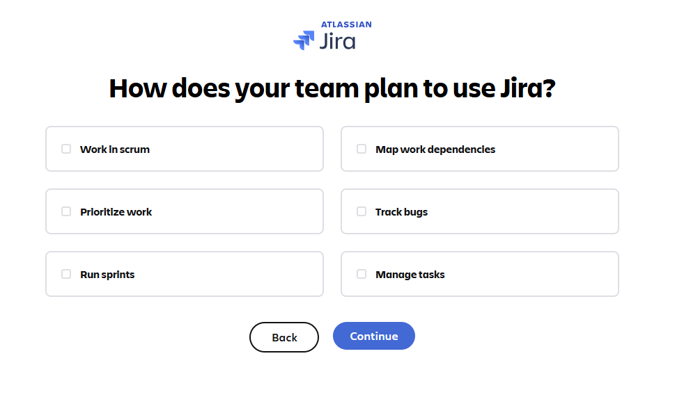

1. **Choose Project Name and Familiarity**

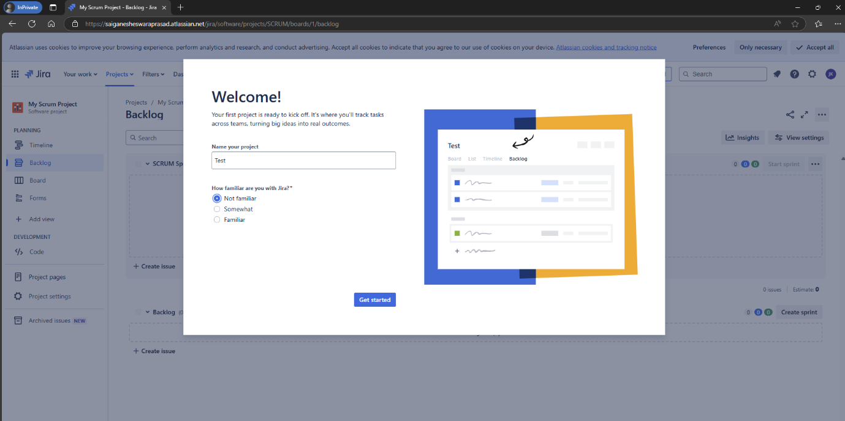

1. 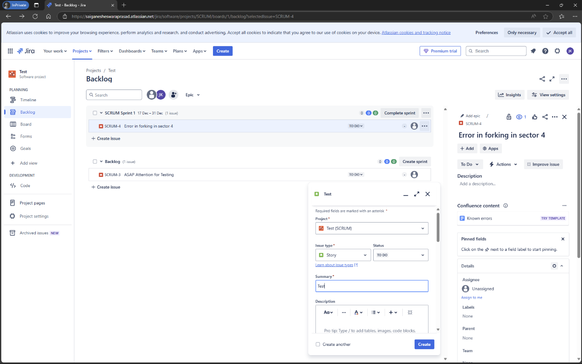**Create Issues in JIRA**
2. **Add Task to Timeline**

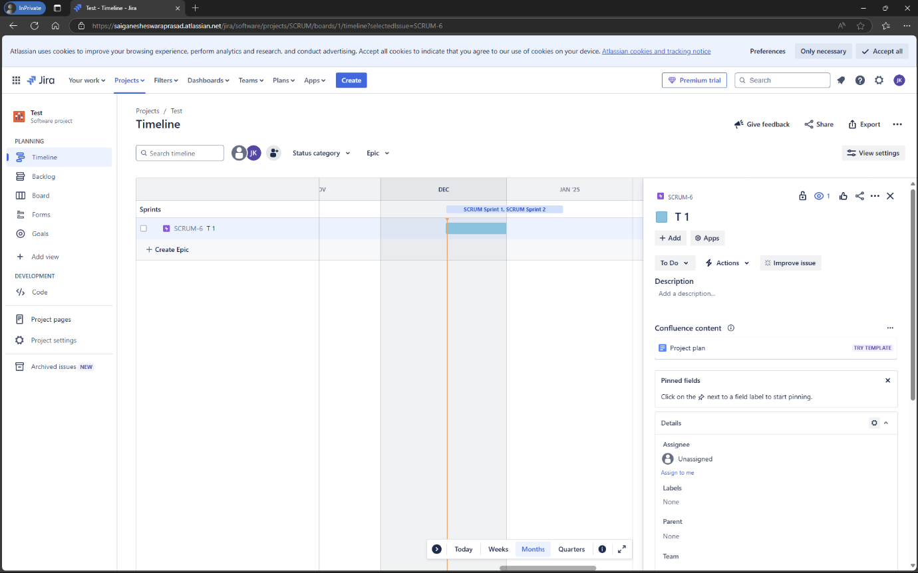

1. 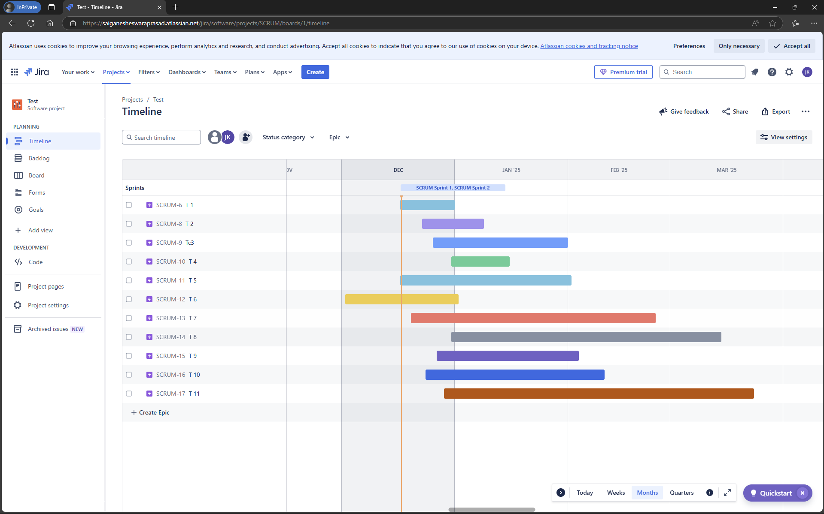**Add multiple Tasks to Timeline and Change Colours**